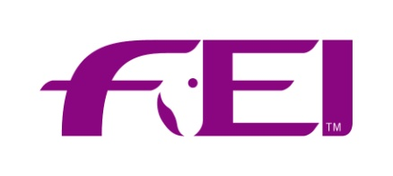
FEI Coaching System 2019
Course Application Form
Please complete this form and return to FEICoaching Department, Andreina Wipraechtiger.
Fax: +41 21 310 47 60
email:andreina.wipraechtiger@fei.org

Course information is available from:
http://inside.fei.org/fei/your-role/coach/about

NATIONAL FEDERATION OF: and its Responsible Person:
informs the FEI that it will organize FEI Coaching courses in 2019

COURSE INFORMATION
 | Course Title | Course Type | Course Language* | Course Dates  (dd.mm.-dd.mm.2019) | Course Location  (City, Venue/Club)
1 | Intro Olympic  (2 days)  Level 1 Olympic  (5 days)  Level 1 Vaulting (4 days)  Level 1 Endurance  (5 days)  Level 2 with Eventing Module  (7 days)  Level 2 without Eventing Module  (6 days)  Level 3 Jumping  (6 days)  Level 3 Eventing  (6 days)  Level 3 Dressage  (6 days) | National  Regional | English  Spanish (not for Vaulting)  French(only L1 Olympic)  Russian(only L1 Olympic + Endurance)  Arabic(only L1 Olympic + Endurance)
2 | Intro Olympic  (2 days)  Level 1 Olympic  (5 days)  Level 1 Vaulting (4 days)  Level 1 Endurance  (5 days)  Level 2 with Eventing Module  (7 days)  Level 2 without Eventing Module  (6 days)  Level 3 Jumping  (6 days)  Level 3 Eventing  (6 days)  Level 3 Dressage  (6 days) | National  Regional | English  Spanish (not for Vaulting)  French (only L1 Olympic)  Russian(only L1 Olympic + Endurance)  Arabic (only L1 Olympic + Endurance)

*The course material is not available in all languages – Vaulting is currently only available in English.
Date:
Signature: Stamp of NF:

